**Probability and Statistics - IT2120**

**Lab Sheet 04**

IT24100762

Atapattu S.K

1.

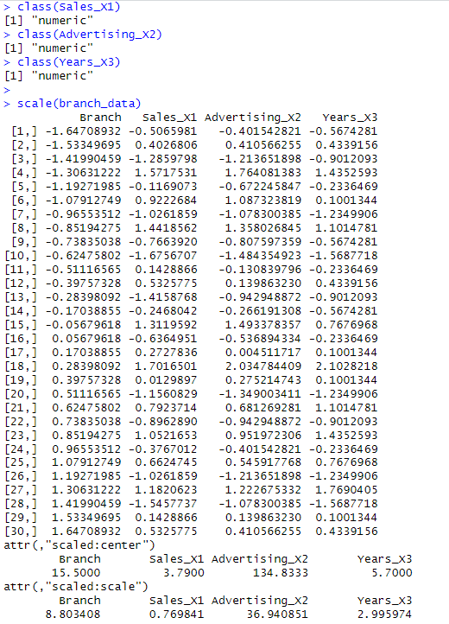2.

3.

4.

5.